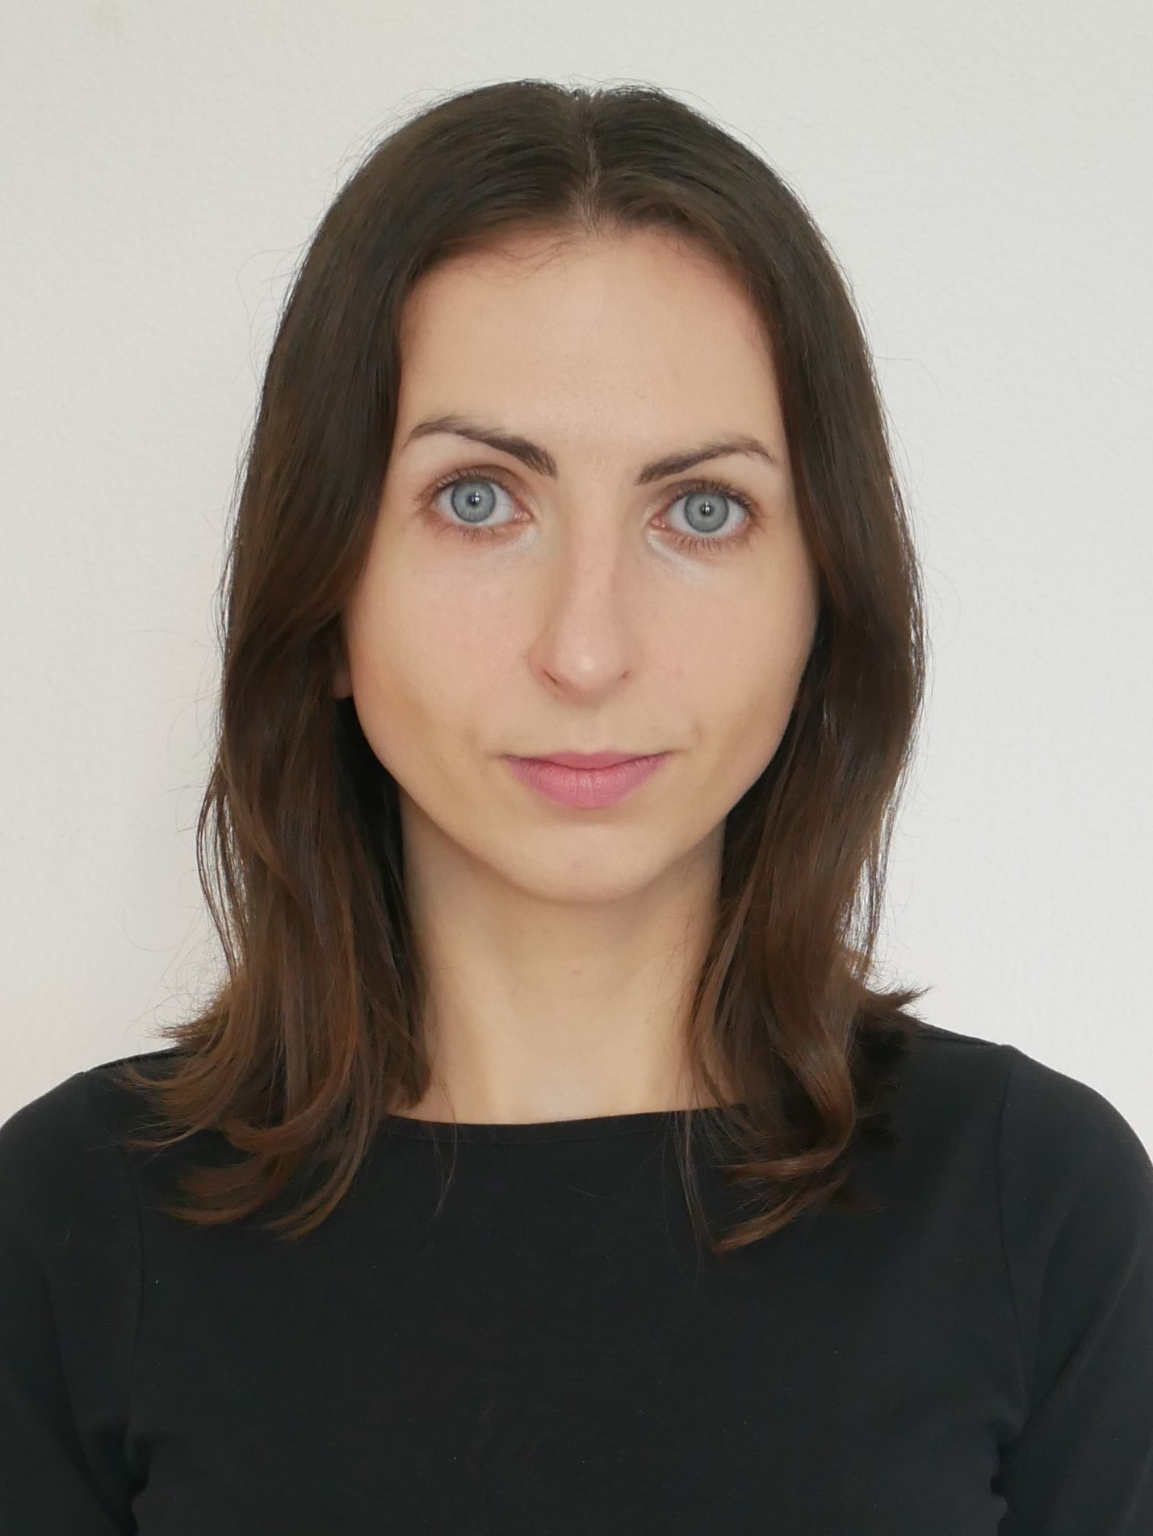  Unity Developer  Ewelina Jurkiewicz | 076 214 70 24
 | 1522 Lucens, Switzerland
 | jrkewelina@gmail.com
 | https://www.linkedin.com/in/ewelina-jurkiewicz/
Autorisation de séjour: Permis B  Nationality: Polish | https://www.eveline-cpp.ch/
– SKILLS –
C/C++/C#  Object-oriented programming, programming language implementation, memory management | Unity  Creation and manipulation: 3D models, animations, textures, objects, and audio sounds | Virtual Reality Technologies  Creating VR applications with Meta Quest 3  Master's thesis based on VR technology
IDE/Version control  Programming and code management  Tools: Visual Studio and GitHub | Project management principles  Agile, Scrum, Kanban  Tools: Jira and GitHub Projects | Software architecture  Understanding various software structures used in application design
UI/UX  Creating mockups with universal design in mind  Tools: Figma | Creating documentation  Knowledge of software development documentation  Tools: LaTeX/Microsoft Office/Libre Office | Applied Mathematics  Geometry, linear algebra, control theory, algorithms and data structures
SQL  Understanding basic structures and commands Tools: MySQL, phpMyAdmin | Cybersecurity  Automated penetration testing and vulnerability analysis. Tools: Kali Linux and Greenbone | Scientific Software  R - Programming for statistical computing  SciLab - Modeling and simulations
– PROJECTS –
The Echo Room application in collaboration with Apico SA, Lucens
2024 | The Echo Room application serves as a simulator for echo reduction in offices. It allows for creating office spaces with structural elements, including acoustic panels, and assessing the ratio of absorbing surface to the total surface area of the room. It also enables virtual tours of the office with the ability to listen to the difference in sound reverberation. The project was developed in collaboration with Apico SA, where my role involved defining client requirements, designing, implementing, testing, and documenting. The most significant system is the sound reverberation dependent on the total surface area of panels in the room. The aim of the application is to visualize installation, enhance communication with interior designers, and provide a rapid assessment of the minimum absorbing surface area.
Lotery Lotto
11/2023 | The game is a simulator of a popular lottery game where the player can draw 6 numbers ranging from 1 to 42, following the rules of a real lottery. The player can go through the entire game cycle, restart it, or pause during gameplay. After drawing all the balls, the lottery results are displayed in ascending order.  This is an independent project in which I created: a 3D game studio, a drawing machine, and balls with textures corresponding to their numbers. Implemented systems include: routines counting down the time until the balls are shuffled and the number drawing begins, user interface elements controlled by scripts such as text fields, buttons, sliders, and game scenarios: Start, Pause, Restart. The Selection Sort algorithm is applied to sort the drawn ball numbers.
– EXPERIENCE –
R&D Master trainee for Immersive Technologies, Societe des Produits Nestle S.A. |  | 
09/2024 – 02/2025
Independent developer, My-Freelance Switzerland
since 2019 | Implementation of projects in the entertainment and industry sectors on Windows, Android, and WebGL applications.
Junior programmer, Apico SA, Lucens
01/2023 – 04/2023 | Participation in project meetings – software engineering, Unified Modeling Language. Unit test programming according to Test-Driven Development – TCUnit, C++, Structured Text. Programming of functions (methods) based on linear algebra – machine motion control – TwinCAT3 Motion Control.

– LANGUAGES–
French | English | Polish
B1 | C1 | native
– EDUCATION –
03/2024 – currently | Master's degree in Computer Science: Higher School of Entrepreneurship and Administration in Lublin, Poland  Field of study: Cybersecurity  Thesis: Study on the Possibility of Using the Unity Engine and VR Technology to Create a Medical Simulation for Suturing
05/2024 | Certificate Game design, Lublin GameDev Foundation
03/2024 | Certificate Unity Certified User Programmer, Unity Technologies
08/2023 – 09/2023 | Attestation of French Language School: Swiss Private Academy
10/2013 – 10/2016 | Bachelor's degree in Mathematics: Stefan Cardinal Wyszyński University in Warsaw, Poland  Specialization: Applied Mathematics in Computer Science

